Project Design Phase-II
Data Flow Diagram & User Stories

Date | 31 January 2025
Team ID
Project Name
Maximum Marks | 4 Marks

Data Flow Diagrams:
A Data Flow Diagram (DFD) is a traditional visual representation of the information flows within a system. A neat and clear DFD can depict the right amount of the system requirement graphically. It shows how data enters and leaves the system, what changes the information, and where data is stored.
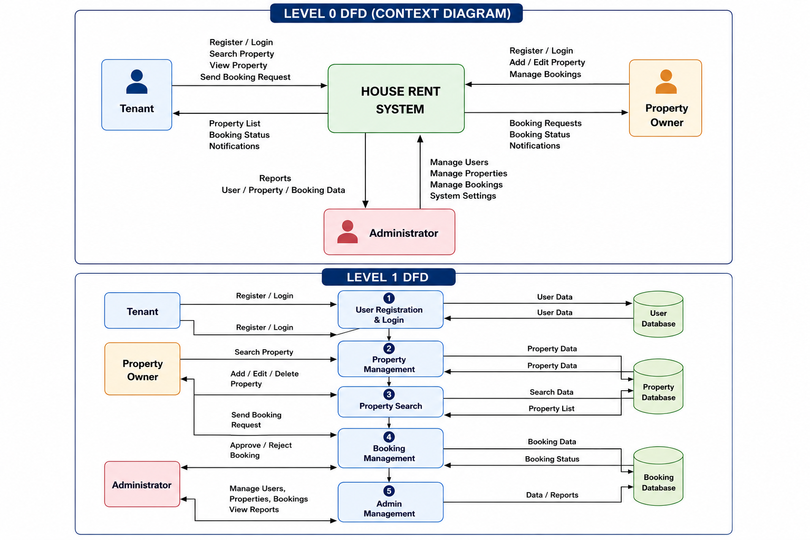
User Stories
Use the below template to list all the user stories for the product.
User Type | Functional Requirement (Epic) | User Story Number | User Story / Task | Acceptance criteria | Priority | Release
Customer (Tenant) | Login | USN-1 | As a Tenant, I can log in using my email and password. | Dashboard opens after successful login. | High | Sprint-1
Customer (Tenant) | Property Search | USN-2 | As a Tenant, I can search properties by location and rent. | Matching properties are displayed. | High | Sprint-1
Customer (Tenant) | Property Booking | USN-3 | As a Tenant, I can send a booking request for a property. | Booking request is sent successfully. | High | Sprint-2
Customer (Tenant) | Booking History | USN-4 | As a Tenant, I can view my booking history. | Previous bookings are displayed. | Medium | Sprint-2
Property Owner | Property Management | USN-5 | As an Owner, I can add a new property with images and details. | Property is successfully listed. | High | Sprint-1
Property Owner | Property Update | USN-6 | As an Owner, I can edit my property information. | Updated details are saved successfully. | High | Sprint-2
Property Owner | Booking Requests | USN-7 | As an Owner, I can approve or reject booking requests. | Booking status is updated correctly. | High | Sprint-2
Administrator | User Management | USN-8 | As an Admin, I can manage users and owners. | User information can be viewed, updated, or removed. | High | Sprint-2
Administrator | Property Management | USN-9 | As an Admin, I can manage all listed properties. | Properties can be approved, updated, or removed | High | Sprint-2
Administrator | Booking Management | USN-10 | As an Admin, I can monitor all booking records. | Booking details are displayed correctly. | Medium | Sprint-3
Administrator | Dashboard | USN-11 | As an Admin, I can view system statistics and reports | Dashboard displays accurate analytics. | Medium | Sprint-3

